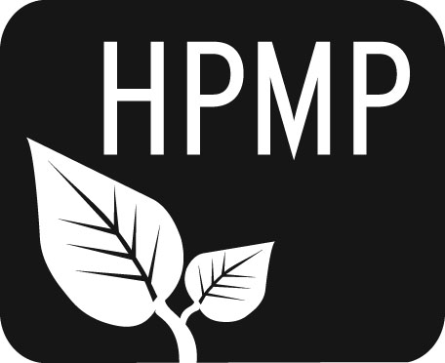
Helena Public Montessori Parents, Inc.
Join us as we support and advocate for public Montessori education

HPMP Meeting notes
Monday, April 7, 2014
5:30-6:30 pm
Broadwater Elementary School
Attendees: Co-President Erin Turner, Secretary Erin Lanigan, Treasurer Heather Nicholson, Smith Representative Tiffany Lyden, Alan Woodmansey, Broadwater Representative Anne Woodland, Future of Montessori Representative Diana Hammer, Central Principal Vanessa Nasset, Michael Kelly, Smith Principal JiLyn Oliveira.

Welcome/Introductions
The meeting was opened with introductions.

Secretary’s Report
The minutes from the March meeting were submitted for approval.

Treasurer’s Report
Balance as of March 31 was 6616.46. Gross amount made for the Not-Its fundraiser was $3427.

Principal’s Report
Orientation for the lottery will be on Thursday, April 10, at Four Georgians. The lottery is on April 23 at 4PM.

The Spring Thing
Overall, the event was a success as an event; as a fundraiser, it did not generate money for the group. There were several suggestions for marketing, signage, tickets, raffle baskets, etc. A full debriefing meeting will be held.

Future of Montessori Report
A meeting with the district is pending. Major changes to how the lottery is advertised and policies regarding gender balance have been the main areas of agreement and new direction thus far. Aligning Montessori policies with district policies has been a main goal. In addition, the district is committed to funding the program at its current level.

2014 Lottery Updates
A mailing went out to every eligible kindergartner in the district this year for the first time. The application for the lottery was part of the mailing. Orientation will be held at Four Georgians, a non-Montessori school, for the first time. There will be gender balance for the first time. There are already applications that have been turned in.

2014-2015 Fundraising Calendar
Discussed briefly, a final recommendation will be presented at the May meeting.

2014-2015 Board Elections
Will be held in May.

The next meeting will be Monday, May 5 at 5:30 pm at Broadwater School.

Helena Public Montessori Parents, Inc. (HPMP) www.helenamontessori.org
PO Box 731, Helena, MT 59624

2013-2014 HPMP Board:
Co-President, Erin Turner (Central parent) erinhturner@gmail.com 443-2496
Co-President, Perri May (Broadwayter parent) yakingmom@gmail.com 442-9202
Treasurer, Heather Nicholson (Central parent) hnicholson@rmdc.net 459-9690
Secretary, Erin Lanigan (Broadwater parent) vanlanigan@gmail.com 431-2690
Future of Montessori, Diana Hammer (Central parent) Diana_hammer@yahoo.com 461-4148
Broadwater School Rep, Anne Woodland awoodland@lucidsi.com 459-6728
Central School Rep, Amy Heuiser adheuiser@gmail.com 461-4228
Smith School Rep, Tiffany Lyden Tiffanylyden@gmail.com 261-6977

