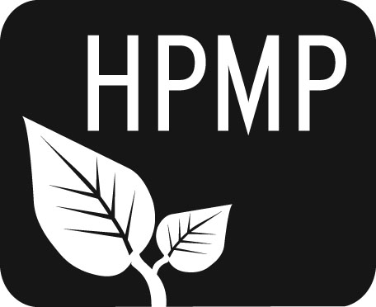
Helena Public Montessori Parents, Inc.
Join us as we support and advocate for public Montessori education

HPMP Meeting notes
Monday, November 3, 2014
5:30-6:30 pm
Central-Linc Elementary School
Attendees: Past President Erin Turner, Secretary Erin Lanigan, Co-President Tiffany Lyden, Alan Woodmansey, Central Principal Vanessa Nasset, Broadwater Principal Sue Sweeney, Central-Linc Upper Elementarty teacher Tony Napoletano, Piper Lynch, Sally Hicks, Sara Groves, Laura Ferguson, Lisa Campbell, Future of Montessori Diana Hammer, Jessica Margotar
Welcome/Introductions
The meeting was opened with introductions.

Secretary’s Report
All thank-yous in Google Drive have been sent out. Are there more to be sent?

Treasurer’s Report
Balance 13,641.07

Principal’s Report
All is well. The District has agreed to help with funding previously given by HPMP. We are still waiting to confirm that they are willing to pay up front for teacher certification and living stipend money. It is looking like there will be a Montessori budget for the three schools that have Montessori pods. Tony Napoletano will be working on his certification over Martin Luther King, Jr. weekend. 30+ children are still on the first grade waiting list. We are looking to fill 3rd and 4th grade student positions at Smith.

State Employees Charitable Giving Campaign
State Employees can elect to donate to HPMP through this campaign.

Original Works
Due Friday November 7

25 Years of Montessori Update
Piper Lynch offered to work on HPMP’s Facebook page to increase updates and make this social media outlet more useful.

HPMP Teacher Scholarships/Teaching Materials Funding Policy Update
Erin Turner and Sue Sweeney are going to meet to work on this. The AMS conference is in Philadelphia March12-15, 2015. We need to figure out how to use the money we raise now that the district is taking over some of our previous funding projects. Carroll College has mentioned the possibility of working on a Montessori training through their education department.

Governor’s Pre-K Initiative – www.earlyedge.mt.gov
There was a hearing today about this initiative for publicly funded ½ day preschool for 4-year olds. HPMP believes preschool funding is important, and some board members are drafting a letter to show support and make sure that Montessori isn’t excluded in this initiative.

The next meeting will be Monday, December 1 at 5:30 pm at Central-Linc School.

Helena Public Montessori Parents, Inc. (HPMP) www.helenamontessori.org
PO Box 731, Helena, MT 59624

2013-2014 HPMP Board:
Co-President, Tiffany Lyden (Smith parent) tiffanylyden@gmail.com 443-2496
Co-President, Perri May (Broadwayter parent) yakingmom@gmail.com 442-9202
Past President, Erin Turner (Central parent) erinturner@gmail.com 443-2496
Treasurer, Heather Nicholson (Central parent) hnicholson@rmdc.net 459-9690
Secretary, Erin Lanigan (Broadwater parent) vanlanigan@gmail.com 431-2690
Future of Montessori, Diana Hammer (Central parent) dianajhammer@gmail.com 461-4148
Broadwater School Rep, Larua Ferguson lkfgreeneyes@hotmail.com 529-3717
Central School Rep, Amy Heuiser adheuiser@gmail.com 461-4228
Smith School Rep, Sara Groves sarajeangroves@hotmail.com 442-0633
Smith School Rep, Alan Woodmansey awoodmansey@yahoo.com 443-6319

