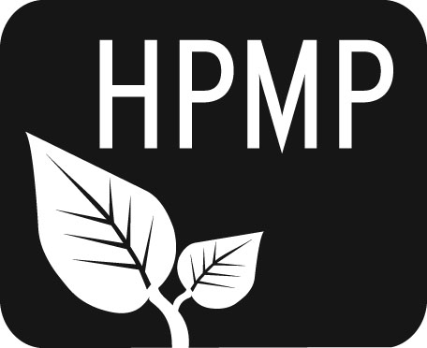
Helena Public Montessori Parents, Inc.
Join us as we support and advocate for public Montessori education

HPMP Meeting notes
Monday, February 3, 2014
5:30-6:30 pm
Broadwater Elementary School
Attendees: Co-President Erin Turner, Co-President Perri May, Secretary Erin Lanigan, Treasurer Heather Nicholson, Smith Representative Tiffany Lyden, Alan Woodmansey, Broadwater Representative Anne Woodland, Alana Listoe, Future of Montessori Representative Diana Hammer, Broadwater Principal Sue Sweeney, Spring Fitzgerald, Sally Hicks, Central Principal Vanessa Nasset, Michael Kelly, Dongbin Xu.
Co-President Perri began the meeting at 5:30 pm.

Welcome/Introductions
Perri opened the meeting with introductions. Erin Lanigan circulated the sign-in sheet.

Secretary’s Report
Erin Lanigan reported thank-yous had been sent.

Treasurer’s Report
Current balance is $3673.11. There is a possibility for United Way funding; this includes writing a grant, and the application is due March 12.

Principal’s Report
Vanessa reported that planning is beginning for the Montessori informational meeting on April 10. An in-touch notice will be going out to all kindergarteners in the district.

The Spring Thing Updates
The Spring Thing will be on April 6 at the Carroll College PE Center. More help is always encouraged for this Helena-wide event. Much planning is going on this month. The Central parent band may be an opening act, and there will be face-painting and food along with other activities.

Karaoke Night
Karaoke Night made $724. A big thank you to Jim Tucker and Perri May for all their work. This is something that could possibly happen a couple of times per year, and we will check in with the Ox to see about this.

Future of Montessori Report
The Montessori program allows for 180 students between the three schools after the Broadwater pod was complete three years ago. There are approximately 70 children who enter into the lottery for 36 first-grade placements. Dr. Kultgen agreed to having a task force with teachers and parents to discuss expansion in the Helena School District. This task force is to have recommendations to Kultgen by the end of February for him to bring to the board in March. If the Montessori program didn’t exist, the district says that the children in Montessori classrooms could be absorbed into traditional classrooms. At this point, the district is talking about moving to 4/3 schools for efficiency, which doesn’t increase class size, but the number of classes in each grade level at these schools. HPMP has provided approximately $270,000 to help with training and Montessori classrooms. Some possible expansion ideas are increasing the class sizes in Montessori, having one school just for Montessori classes, and including 6th grade Montessori in the 4th and 5th grade classrooms. Another idea was to ask parents to fill out a form at the Montessori orientation as to why they are putting their child in the lottery. The group shared some time doing this at the meeting and there were a large variety of reasons.

Kidworks Report
Kidworks will be held March 15. We make a $600 profit on this event.

Meeting was adjourned at 6PM.

The next meeting will be Monday, March 3 at 5:30 pm at Broadwater School.

Helena Public Montessori Parents, Inc. (HPMP) www.helenamontessori.org
PO Box 731, Helena, MT 59624

2013-2014 HPMP Board:
Co-President, Erin Turner (Central parent) erinhturner@gmail.com 443-2496
Co-President, Perri May (Broadwayter parent) yakingmom@gmail.com 442-9202
Treasurer, Heather Nicholson (Central parent) hnicholson@rmdc.net 459-9690
Secretary, Erin Lanigan (Broadwater parent) vanlanigan@gmail.com 431-2690
Future of Montessori, Diana Hammer (Central parent) Diana_hammer@yahoo.com 461-4148
Broadwater School Rep, Anne Woodland awoodland@lucidsi.com 459-6728
Central School Rep, Amy Heuiser adheuiser@gmail.com 461-4228
Smith School Rep, Tiffany Lyden Tiffanylyden@gmail.com 261-6977

