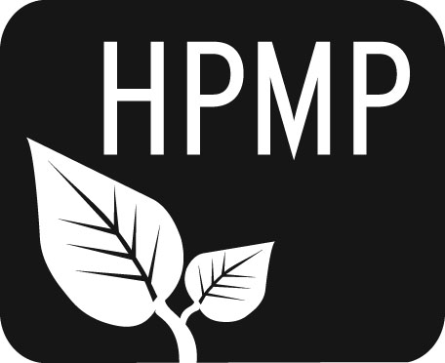
Helena Public Montessori Parents, Inc.
Join us as we support and advocate for public Montessori education

HPMP Meeting notes
Monday, December 1, 2014
5:30-6:30 pm
Central-Linc Elementary School
Attendees: Past President Erin Turner, Secretary Erin Lanigan, Co-President Perri May, Alan Woodmansey, Broadwater Principal Sue Sweeney, Piper Lynch, Laura Ferguson, Co-President Tiffany Lyden, Secretary Heather Nicholson
Welcome/Introductions
The meeting was opened with introductions.

Secretary’s Report
All thank-yous have been sent

Treasurer’s Report
Balance 13,641.07

Principal’s Report
- Sue Sweeney has taken over as the lead administrator for the Helena Public Montessori program.
- We are moving forward with the idea of a summer camp fundraiser for HPMP, as we can use a school building. HPMP would pay for teachers and supplies.
- Sue has asked to have Montessori professional development classes in January and February. This request has not yet been approved.
- 3,333 per Montessori pod (two lower and one upper elementary) at Broadwater, Smith and Central-Linc has been given by the district for materials.
- It is time to start thinking about the Montessori Lottery for this spring

Superintendent’s Parent Advisory Council (PAC) Report
- Alan Woodmansey is the Smith representative

HPMP Goals
- Diana Hammer has a copy of a letter outlining the goals of HPMP
- Expansion is always our goal

Teacher Scholarships/Montessori Materials
- Ms. Bangert is supportive of Montessori
- Is a Kindergarten Montessori a possible move?
- We want to use the money we raise to offer continuing education to current teachers and others interested
- We are working toward formalizing a funding policy

Governor’s Pre-K Initiative – www.earlyedge.mt.gov
- HPMP sent a letter to the Board of Public Education

HPMP Facebook Page/Social Media
- Piper is working to access and update the HPMP Facebook page and use it to post updates on 25 Years of Montessori

Potential Events/Fundraisers for 2015
- Karaoke Night
- Film Festival
- Kidworks
- Spring Thing
- 25 Years of Montessori
- Summer Camps
- A meeting will be held on January 5 specifically to plan for fundraisers

The next meeting will be Monday, February 2 at 5:30 pm at Central-Linc School.

Helena Public Montessori Parents, Inc. (HPMP) www.helenamontessori.org
PO Box 731, Helena, MT 59624

2013-2014 HPMP Board:
Co-President, Tiffany Lyden (Smith parent) tiffanylyden@gmail.com 443-2496
Co-President, Perri May (Broadwayter parent) yakingmom@gmail.com 442-9202
Past President, Erin Turner (Central parent) erinturner@gmail.com 443-2496
Treasurer, Heather Nicholson (Central parent) hnicholson@rmdc.net 459-9690
Secretary, Erin Lanigan (Broadwater parent) vanlanigan@gmail.com 431-2690
Future of Montessori, Diana Hammer (Central parent) dianajhammer@gmail.com 461-4148
Broadwater School Rep, Larua Ferguson lkfgreeneyes@hotmail.com 529-3717
Central School Rep, Amy Heuiser adheuiser@gmail.com 461-4228
Smith School Rep, Sara Groves sarajeangroves@hotmail.com 442-0633
Smith School Rep, Alan Woodmansey awoodmansey@yahoo.com 443-6319

