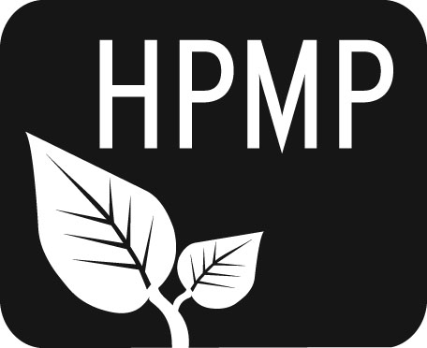
Helena Public Montessori Parents, Inc.
Join us as we support and advocate for public Montessori education

HPMP Meeting notes
Monday, January 6, 2014
5:30-6:30 pm
Broadwater Elementary School
Attendees: Co-President Erin Turner, Co-President Perri May, Secretary Erin Lanigan, Treasurer Heather Nicholson, Smith Representative Tiffany Lyden, Alan Woodmansey, Broadwater Representative Anne Woodland, Alana Listoe, Smith Principal Jilyn Oliveira, Central Representative Amy Heuiser.
Co-President Perri began the meeting at 5:30 pm.

Welcome/Introductions
Perri opened the meeting with introductions. Erin Lanigan circulated the sign-in sheet.

Secretary’s Report
Erin Lanigan reported thank-yous had been sent.

Treasurer’s Report
Current balance is $5648.13.

Principal’s Report
Jilyn reported that the first school day in 2014 was done, and kindergarten registration thus far had been busy.

The Spring Thing Updates
The Spring Thing will be on April 6 at the Carroll College PE Center. More help is always encouraged for this Helena-wide event. There will be an upcoming work meeting for the event. The sponsorship letter is finished and needs to be distributed.

Karaoke Night
Karaoke Night will be at the Ox Saturday, January 25. It will cost $1 per ticket to sing, and $2 per ticket to nominate someone else to sing. Perri created an awesome poster for the event. Jim Tucker agreed to DJ (thank you!). A karaoke machine has been reserved through Party Plus.

Future of Montessori Report
A meeting was held to discuss Montessori accessibility and expansion. In this initial meeting, all of the challenges were brought up, as was likely. The nine Montessori teachers are all additional full time employees in the district. The children from these classrooms could theoretically be put into traditional classrooms and teacher numbers would not have to change. The Montessori program also carries with it a perception of elitism, which could be remedied by increasing the number of placements and expanding the lottery. If there is expansion in the Montessori program, it looks like it will be easier to move forward with elementary classrooms before middle school or pre-k. Another meeting will be set up soon for further discussion.

Kidworks Report
Tiffany and Heather will be working together on this project and finding a date for the event.

Meeting was adjourned at 6PM.

The next meeting will be Monday, February 3 at 5:30 pm at Broadwater School.

Helena Public Montessori Parents, Inc. (HPMP) www.helenamontessori.org
PO Box 731, Helena, MT 59624

2012-2013 HPMP Board:
Co-President, Erin Turner (Central parent) erinhturner@gmail.com 443-2496
Co-President, Perri May (Broadwayter parent) yakingmom@gmail.com 442-9202
Treasurer, Heather Nicholson (Central parent) hnicholson@rmdc.net 459-9690
Secretary, Erin Lanigan (Broadwater parent) vanlanigan@gmail.com 431-2690
Future of Montessori, Diana Hammer (Central parent) Diana_hammer@yahoo.com 461-4148
Broadwater School Rep, Anne Woodland awoodland@lucidsi.com 459-6728
Central School Rep, Amy Heuiser adheuiser@gmail.com 461-4228
Smith School Rep, Tiffany Lyden Tiffanylyden@gmail.com 261-6977

